Chronicles of Humanity Order Form
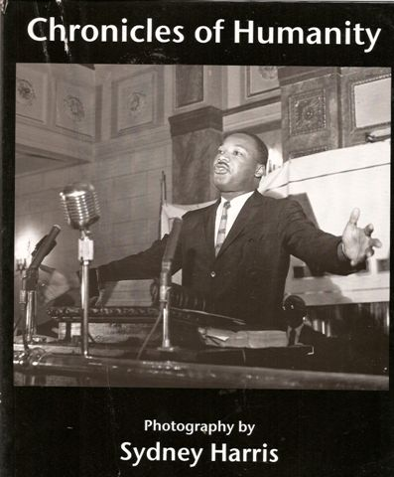
Syd Harris was a committed photographer with a beautiful eye for humanity. His direct, social realist style is unassuming yet revelatory. Harris, a veteran of the Spanish Civil War and Lincoln Brigade, worked as a photographer and journalist for many of the major unions in Chicago from the mid 1950's until his death in 1989.
His works show us the "city of big shoulders". Black, Latino, and White workers from the steel mills, auto plants, and kitchens of fancy hotels are portrayed here--working class men and women now fading from today's world of computers and factory shut-downs.

Caught too are major political and cultural figures of the 1960's. Here is Dr. King leading street protests, Carl Sandburg reading a poem, Paul Robeson challenging power and President Kennedy staring intently at a young woman across his banquet table.
Included are photos never before shown of the emergency care room as protestors stagger in bloody and beaten by the Chicago police during the 1968 Democratic convention. This photo book is an insightful historical record and treasure of urban industrial America and those days when picket lines and demonstrations changed the country.

Please Print Clearly

Name________________________________________________________

Address_______________________________________________________

City___________________________________________________________

State/Province___________________________________________________

Postal Code_____________________________________________________

Country________________________________________________________

# | Description | Cost | Total
 | Chronicles of Humanity  Heavy stock paper, 72 pages, 120 photos | $16.00
 |  | Subtotal
 |  | 1st Class Shipping | Free
 |  | Total Enclosed
Make checks payable to: Jerry Harris

Send to:
Jerry Harris
1250 N. Wood Street
2nd Floor
Chicago, IL, 60622

